Download Onboarding Project From GIT

This document provides instructions on downloading the onboarding project from Git, placing it in the correct location on your computer, and building it.
Open GitExtensions or any other software you are acomfortable to work with git. from your computer and click “Clone Repository”.
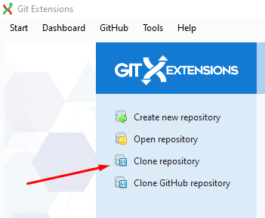

If you don’t have GitExtensions installed on your computer, you can download it from here http://gitextensions.github.io/

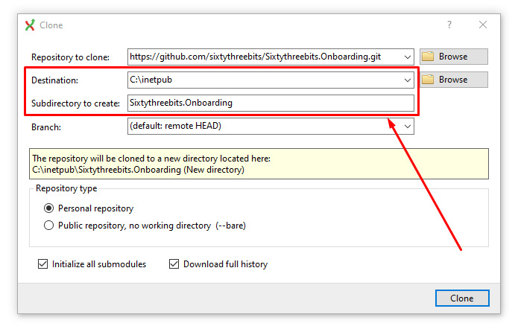

Fill the fields presented by “clone” window with following values:
- Repository to clone: https://github.com/sixtythreebits/Sixtythreebits.Onboarding.git
- Destination: C:\inetpub
- Subdirectory to create: SixtyThreeBits.Onboarding
Open SixtyThreeBits.Onboarding.sln solution file with your visual studio.
Open Solution Explorer -> SixtyThreeBits.Web -> wwwroot and check if “upload” folder exists. In case there is no “upload” folder, create new folder and name it “upload”.

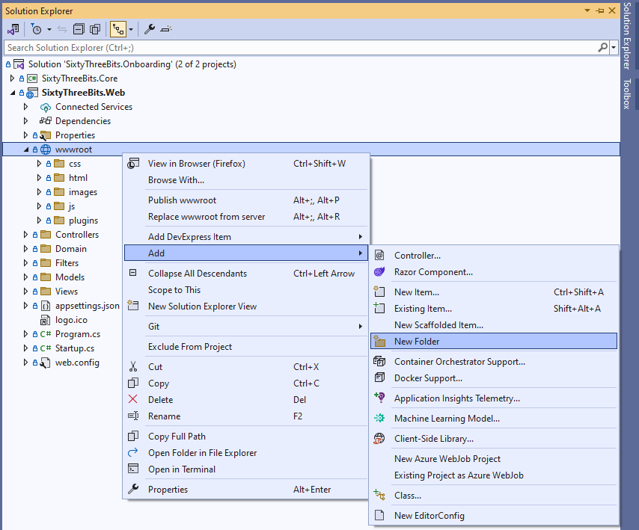

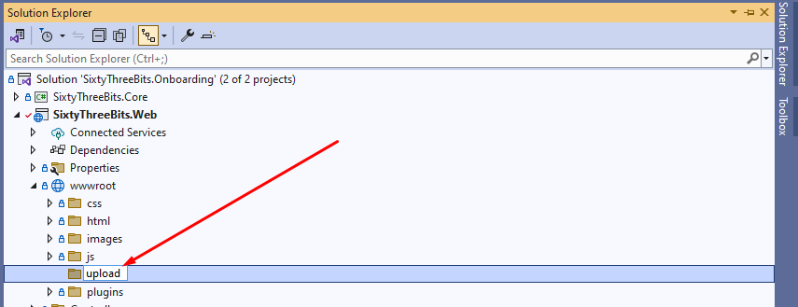

Next, open Solution Explorer -> SixtyThreeBits.Web -> appsettings.json file

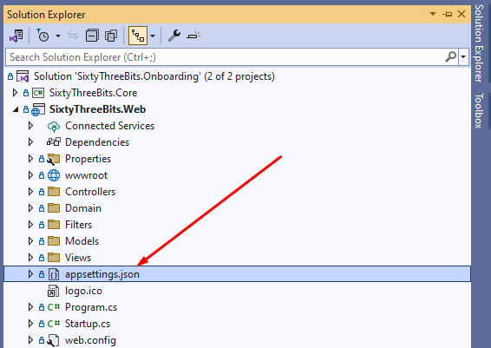

Change database name for DbConnectionString to your database name and connection string.

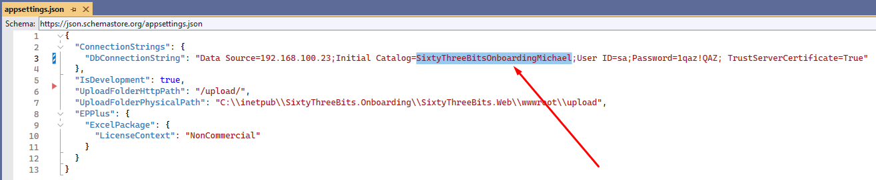

Next, open Solution Explorer -> SixtyThreeBits.Web -> Properties -> launchSettings.json file
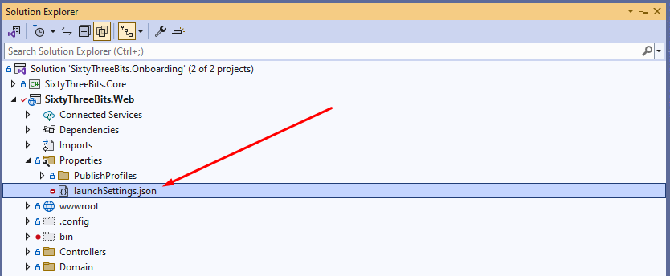

and make sure it looks like json below. if not, just overwrite json from below to your launchSettings.json file.
{
"profiles": {
"IIS Express": {
"commandName": "IISExpress",
"launchBrowser": true,
"environmentVariables": {
"ASPNETCORE_ENVIRONMENT": "Development"
}
},
"SixtyThreeBits.Web": {
"commandName": "Project",
"launchBrowser": true,
"environmentVariables": {
"ASPNETCORE_ENVIRONMENT": "Development"
},
"applicationUrl": "http://localhost:5000"
}
},
"iisSettings": {
"windowsAuthentication": false,
"anonymousAuthentication": true,
"iisExpress": {
"applicationUrl": "http://localhost:41200",
"sslPort": 0
}
}
}

Next, open Solution Explorer, right click on SixtyThreeBits.Onboarding solution and click “Rebuild Solution”.
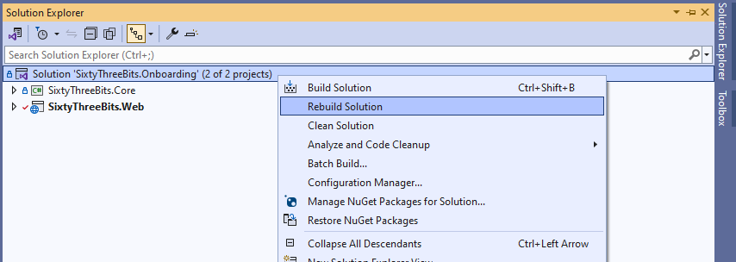

Success message should appear, in output window upon successful build.
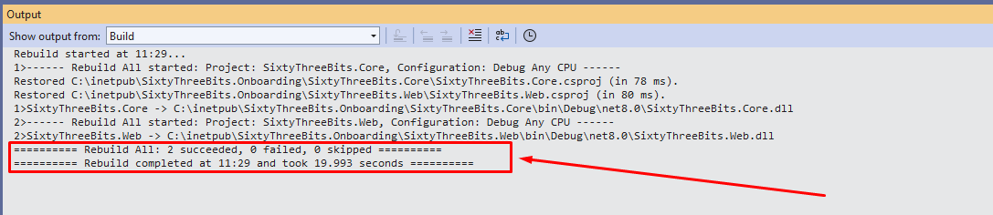

Next, hit CTRL + F5 on the keyboard to run project in the browser. Visual studio should launch project and open browser window. This is what should be displayed in the browser:
